Chapter 7, Problem 76.

Repeat Prob. 7.40 using PSpice.

Chapter 7, Problem 49.

If the waveform in Fig. 7.116(a) is applied to the circuit of Fig. 7.116(b), find v(t). Assume v(0) = 0.

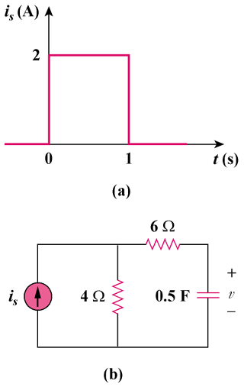

Figure 7.116
For Prob. 7.76.

